Section-End Project - Lesson 4

Data Structures - Arrays and Lists

# The following exercises will give you the needed exposure to solving some Linked List Coding Problems from Technical Interviews. Write the code in a Java Project called “Collections”.

Q1. **How do you find the middle element of a singly linked list in one pass?**

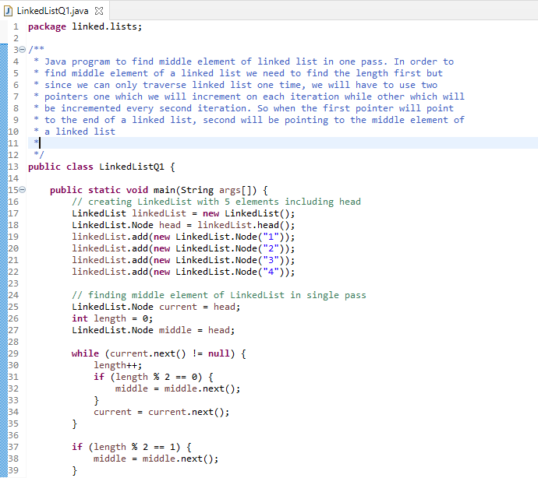

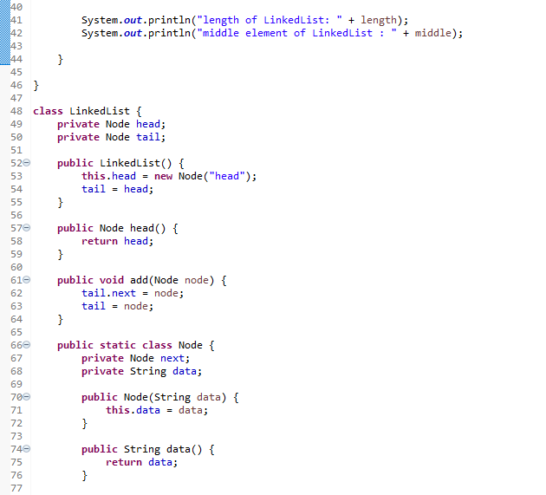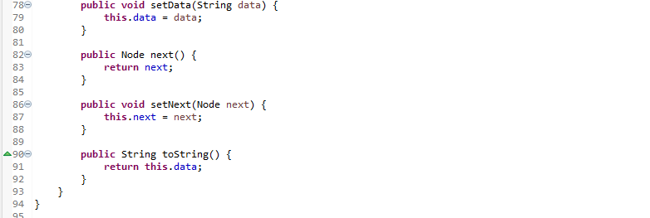

Q2. How do you check if a given linked list contains a cycle? How do you find the starting node of the cycle?

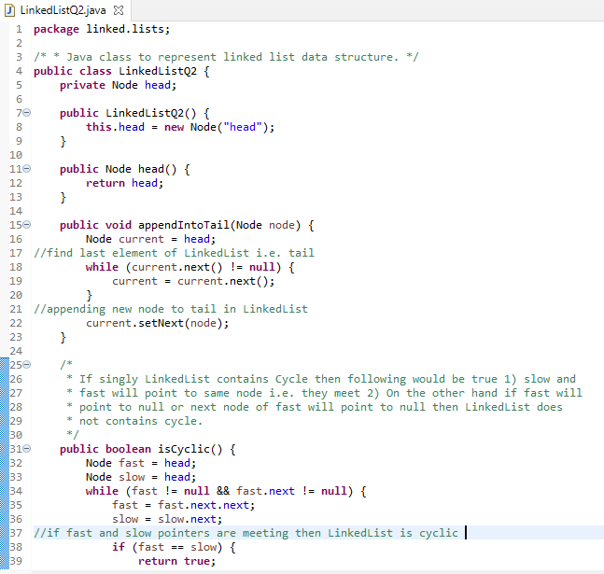

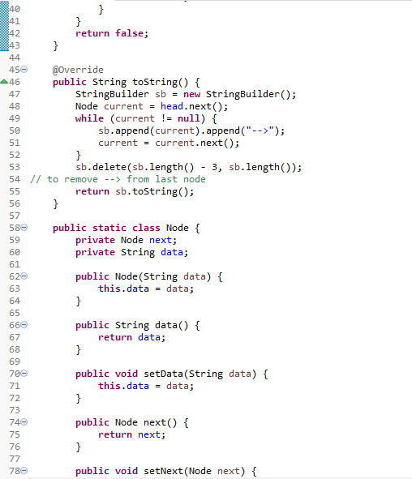

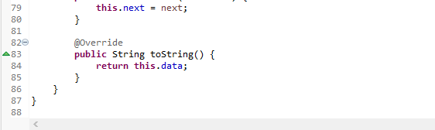

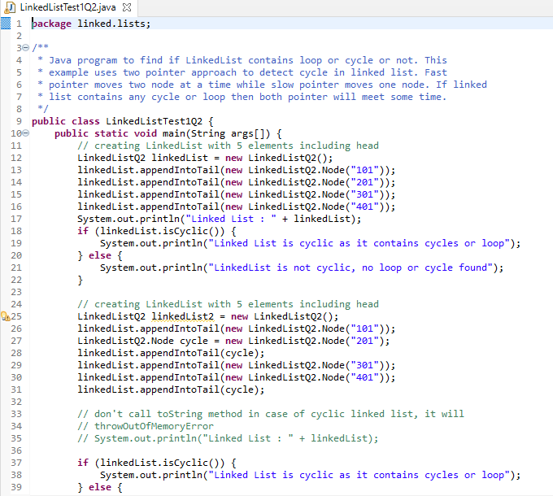

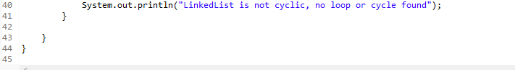

Q3. How do you reverse a linked list?



